**A Method for Superb Culturing of Patient’s T cells:**

**A Novel Technique for Enhanced Expansion and Function of Therapeutic T cells**

|  |  |
| --- | --- |
| **Project Number:** | 1810 |
| **Principal Investigators:** | Prof. Benjamin Geiger  Prof. Nir Friedman |
| **Patent Status:** | Pending |
| **Last Updated:** | 24-06-2018 (1) |

**Overview**

**A novel method that enhances the expansion and function of T cells by a combination of immobilized T cell stimulator and a soluble cytokine.**

**Background and Unmet Need**

Culturing and expanding T cells *ex-vivo*, while retaining their functionality, is an essential requirement when developing cutting-edge immunotherapies. A major problem frequently faced by industry is the low number of T cells available for adoptive immunotherapy, and the difficulty to retain their functionality following extended incubation and expansion *ex vivo*. Specifically, cultivation of T-cells commonly leads to short-term cell proliferation, which is followed by gradual loss of functionality, growth arrest, and increased cell death. **Consequently, there is a strong need for the development of novel technologies that could increase T-cell proliferation, while maintaining, or even enhancing their functionality.**

**The Innovation**

The teams of Profs. Geiger and Friedman have discovered a novel set of conditions that address the unmet needs described above.

**The Technical Essence:**

The Geiger-Friedman research team discovered that by coating culturing vessels with CCL21 they can significantly increase the numbers of T cells. The team hypothesized that the large three-dimensional clusters of T cells that are produced in such cultures inhibit further expansion, and limit their ability to respond to soluble signals. Therefore, the team attached ICAM1 to the culture surface, resulting in flat cultures that yielded less interactions of T cell among themselves. The combined coating with CCL21 and ICAM1 leads to a significant increase in the growth of the T cells as seen in the figure herein for CD4+ T cells. Further optimization of conditions was found by adding IL6 to the culture medium. Notably, stimulation of the cells was not limited to antigen-loaded dendritic cells, and was also achieved by the common procedure of using anti-CD3/anti-CD28 coated beads. To conclude, the new combination used by the team resulted in a considerable increase in the number and function of viable T cells after a few days in culture.

Comparing the expansion of CD4+ T cells in culture vessels with no coating (red), and with surfaces coated with CCL21 only (blue), ICAM1 only (green), and CCL21 + ICAM1 (purple). (Image modified from Adutler-Lieber S, Zaretsky I, Sabanay H, Kartvelishvily W, Golani O, Geiger B and Friedman N. Blood Advances 2017 1:1016-1030.)

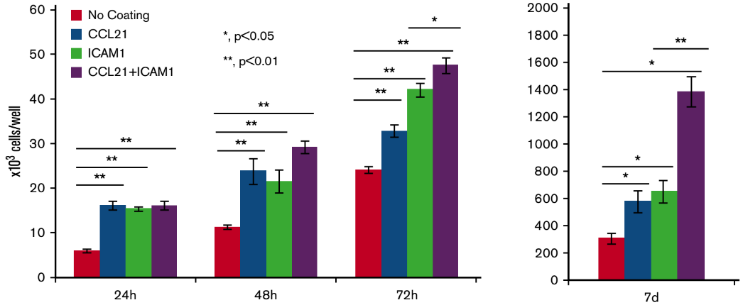

**Applications and Advantages:**

* Expanding large quantities of CD4+ and CD8+ T cells *ex-vivo*, for example tumor infiltrating T cells (TILs) from biopsies.
* Producing highly functional antigen-specific CD8+ T cells for tumor suppression.
* Capacity to stimulate functional CAR-Ts and TILs.
* Simple – coating vessels with the particular T cell stimulatory factors that are commercially available.
* Specific – Co-culturing with antigen loaded dendritic cells allows antigen-specific T cell expansion (e.g. cancer neo-antigen T cells).

**Development Status**

The teams of Profs. Geiger and Friedman have tested numerous conditions on CD4+ and CD8+ T cells to define the optimal **"synthetic immune niche"** for growing said cells. The teams have performed *in vitro* tests to increase CD4+ and CD8+ T cell expansion and function. They have further tested the cells in vivo as an adoptive immunotherapy.

**For additional information please contact:**

Dr. Shay Sela  
VP Business Development Life Sciences  
Tel: +972.8.9344095  
Email: Shay.Sela@weizmann.ac.il